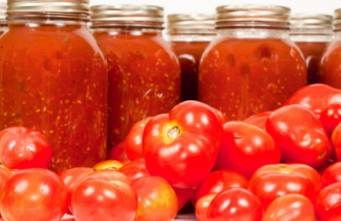
Hearth & Home – Help Us Cook This Up!
Old-Fashioned Days Survey – Bring this to our booth or we'll have one waiting for you. hampshirehistory.org
We're building a Hearth & Home community — a place where those who know how and those who wish they did can connect, learn, and share.

Join us downtown Hampshire at our Old-Fashioned Days booth Saturday, June 6 | 1:00 p.m. – 5:00 p.m.
1. Which best describes you? (check all that apply)
☐ I know how to do some of this stuff ☐ I used to know… it's been a while
☐ I'd love to learn ☐ I'd love to teach ☐ I came for the conversation

2. What would you like to learn or share?
Skill | Learn | Teach
Canning & Preserving | ☐ | ☐
Crocheting / Knitting | ☐ | ☐
Quilting / Sewing | ☐ | ☐
Gardening | ☐ | ☐
Baking | ☐ | ☐
Other __________ | ☐ | ☐

3. Tell us more about what you could teach, demonstrate, or share someday? (No need to be an expert.)
_________________________________________________________________________________________

4. Who taught you something you’ll never forget? What was it?
_________________________________________________________________________________________

5. Be honest… what would get you to show up?

☐ Hands-on workshops ☐ Watching and learning (no pressure)
☐ Small, casual groups ☐ Something unique (garden or in-home demonstration, etc.)
☐ Food involved always helps

6. Want to stay in the loop?
Name ________________________________ Email _____________________________________

Thank you — you're helping us decide what to offer next! A STEP BACK IN TIME PROGRAM


